User experience report

Individual Project Semester 3

Mihail Vasilev

Date: 25.11.2022

# Introduction

The purpose of this report is to outline the different decisions that were taken while creating the front-end user experience on the CarShop individual project. It will contain reports from test users and reports on how the issues were solved and how the fixes affected the application and the user experience. *This document is a continuous work in progress and will be updated with each new feature added.*

# Normal user pages

All of the pages below are specifically for the normal users. Admin users do not have access to these pages and the functionalities that these pages provide.

## Home page

The home page went through a lot of iterations but the main idea was liked by the test users and evolved over time. The page has the navbar on top. After that it has the search menu where the users can select their search parameters and find whatever they need. Below it are displayed the advertisements on the website. In the picture below you can see the first iteration shown to the test users.

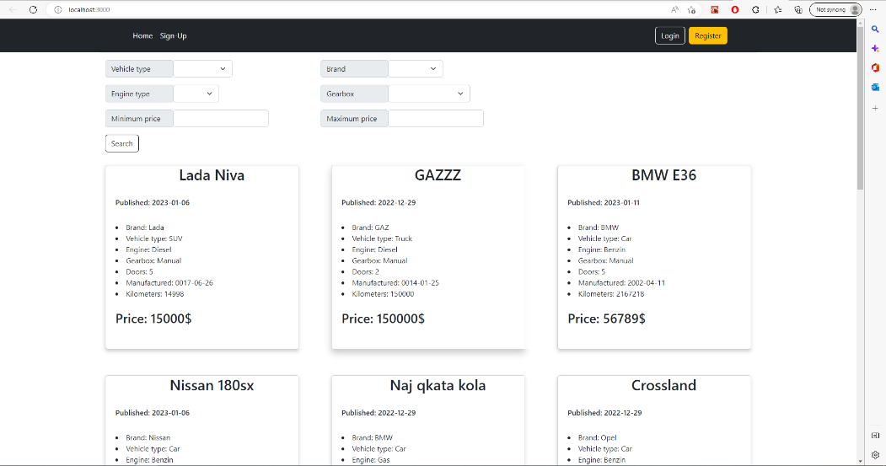

They liked the navigation bar and the search menu but not so much the way the advertisements were displayed. They wanted also to see the pictures of the cars. Their reasoning was that it would be easier for them to decide which one they liked without having to click on every one to go to another page to see the pictures there. In the end below is the final iteration of the design of the home page that was liked by the test users.

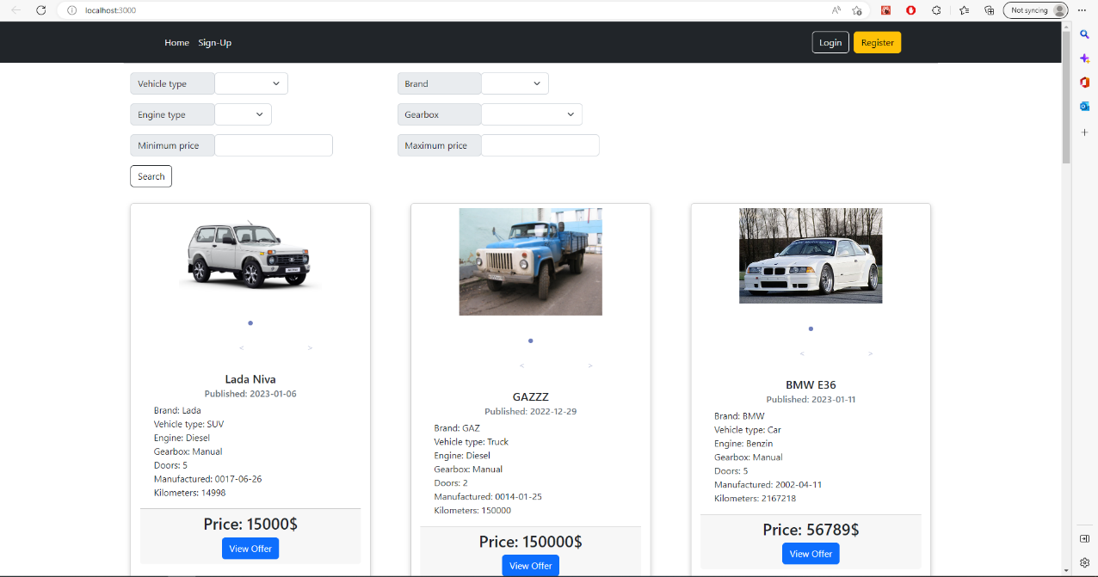

# Register

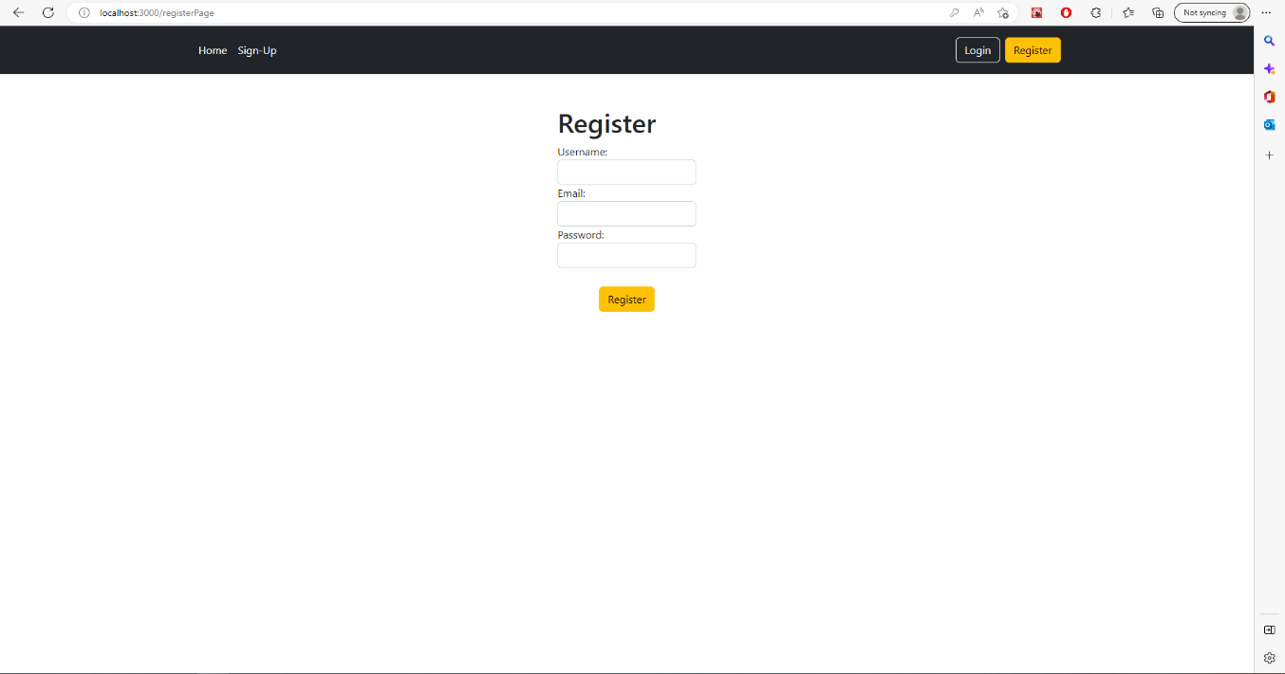 The register functionality was the next thing tested by the users. Overall, their feedback was positive. The register page was kept as clean as possible so that it would be easy for the users to read and fill in the required fields. Not many changes were done to it except that the font was made a bit bigger so that it would be easier to read for the users. Below you can see the final version of the register page.

# Login

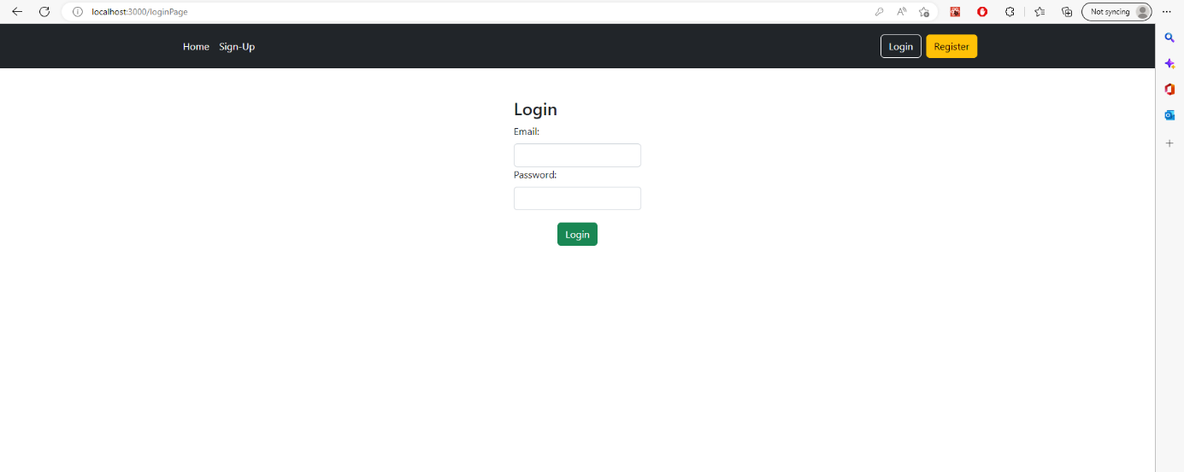 The login was Their feedback was overall positive however a small change in font size was needed to make the text for the required fields more readable and easier to understand. After the changes were implemented, the UI looks much better and is more convenient for the users. Below you can see the final version of the login page.

# Account Details

The account details page received overall positive feedback from the testers. They preferred a minimalistic style for the page and wanted to keep the layout as simple as possible. This was readability and navigating would be increased. In the end only the most important information about the users was kept on screen and only the important functionality was kept. Below you can see the final version of the account details page.

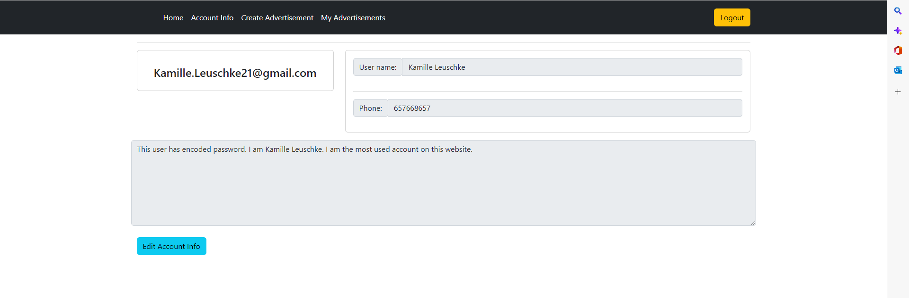

# Create Advertisement

The page for creating advertisements went through a few iterations with some changes to the overall design. The testers wanted a clean and easy to read interface so only the important details were kept. Overall, the feedback was positive. The last change that had to be made was a popup message for when the pictures of the advertisement were updated so that the users knew that their changes had been applied. Below you can see the final version of the page. 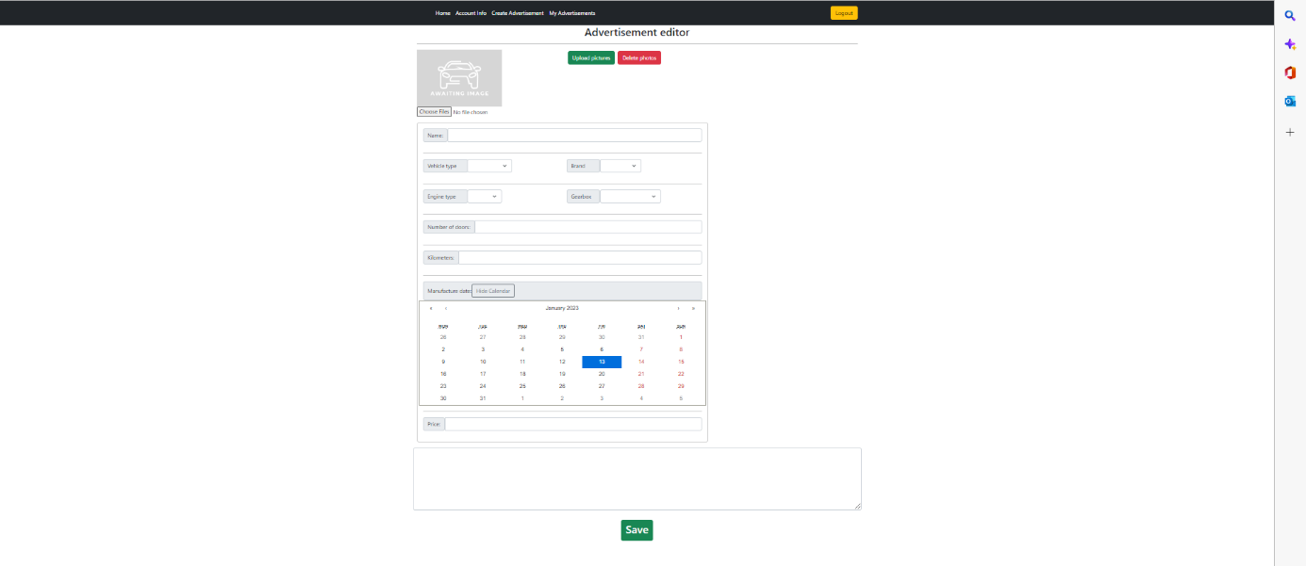

# My Advertisements

The my advertisements page had the most changes being applied to it after the user experience tests. This is the page that contains all the advertisements that the currently logged user has created. The layout was completely redesigned and was made so that each of the displayed items was shown their pictures as well. The buttons were moved and made move visible. Below is the old design of the page.

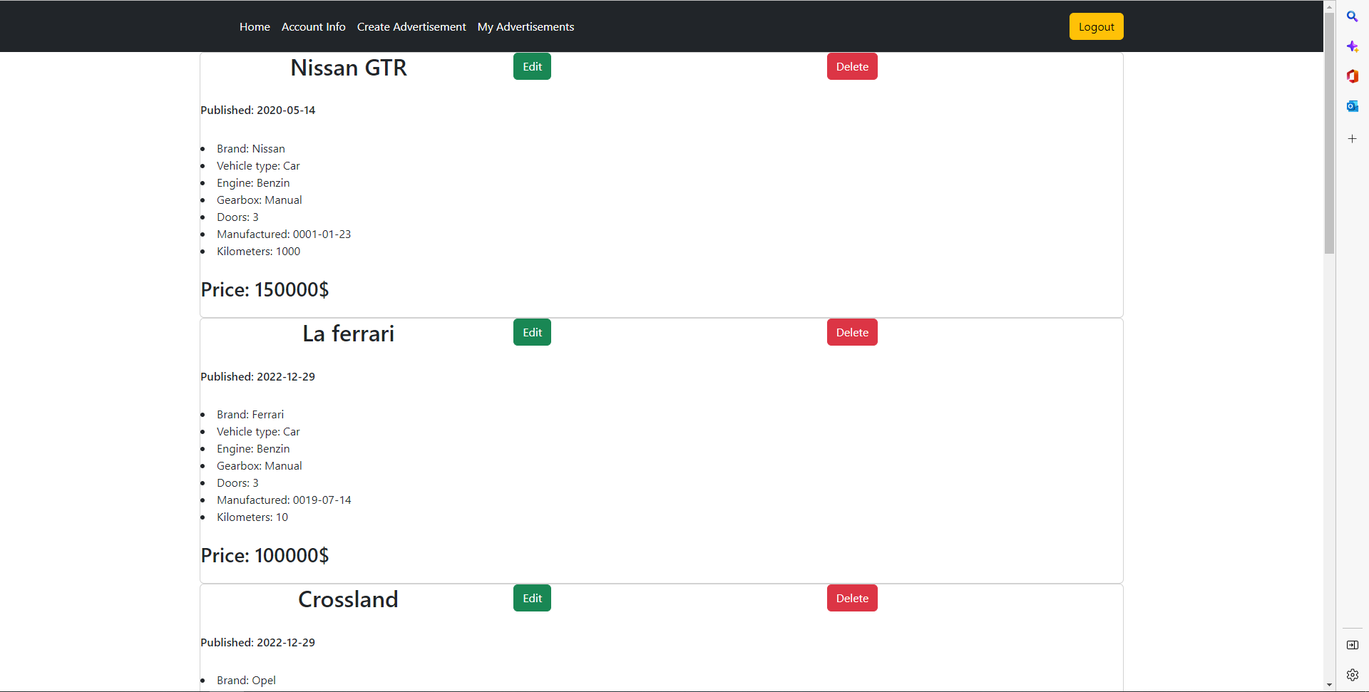

After the feedback the page design was made according to the testers’ feedback and in the picture below you can see the final version of the my advertisements page.

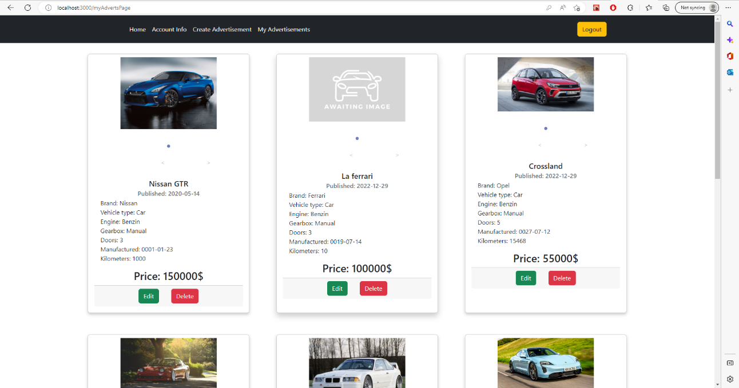

# Admin pages

All of the pages below are specifically for use of the admin users. Other users do not have access to these pages and to these functionalities.

# 

# Admin Home

The admin home page went through a bit of changes, mainly the test users wanted all the navigation for the pages to be on the home page. They also preferred a clean and not very complicated user interface. In the end the page was split into two main parts – the left side is for the parameters and the right side is for the statistics. The page displays the buttons that lead to the other admin pages. Below you can see the final version of the admin home page.

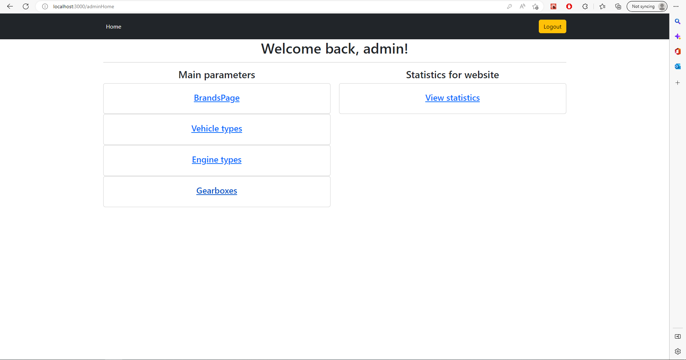

# Brands Page

The brands page is the next page that was tested. In this page the admins can create the parameters for the brands that can be offered on the website. The users tested the page and determined that it was good and not overcrowded, containing only the important information and controls needed. Below you can see the final version of the brands page.

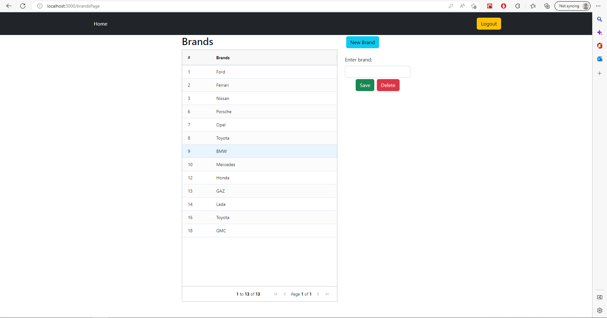

## Vehicle Types page

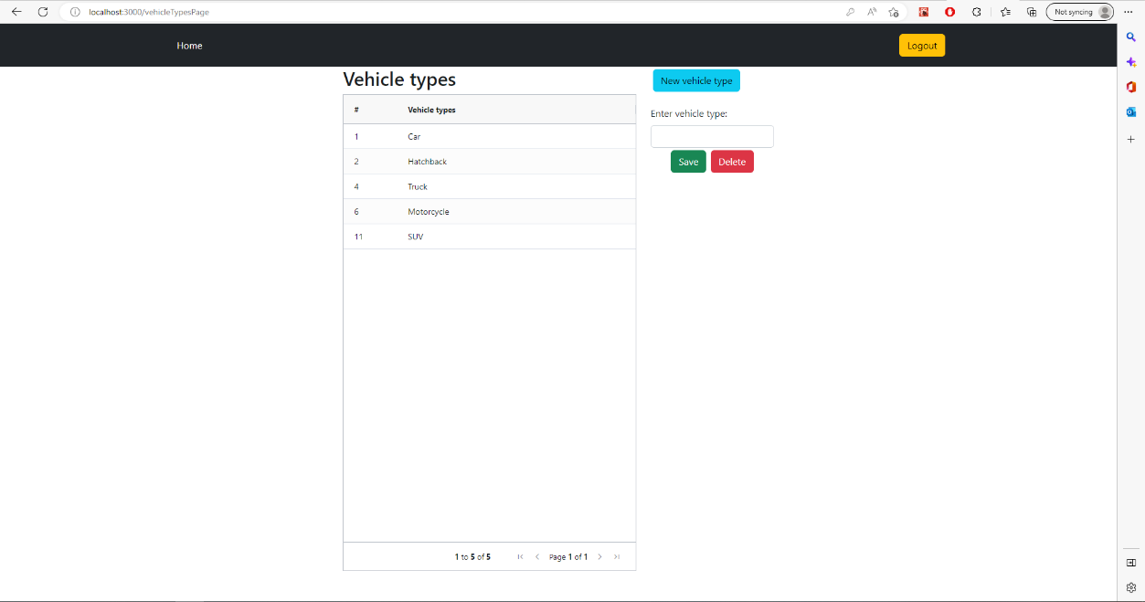 The vehicle types page has the same design layout as the brands page but this time it is used to enter the parameters for the type of vehicle can be offered on the website. The admin users tested the page and determined that it was containing only the important information and controls needed. They liked the minimalistic style and the page saw little change. Below you can see the final version of the vehicle types page.

## Engine types page

The engine types page continues on the design from the previous parameter pages. This page is for entering the parameters for the type of engine the vehicles can have that are offered on the website. The feedback from the users was similar and the layout was kept the same with clean and easy to understand interface. Below you can see the final version of the engine types page.

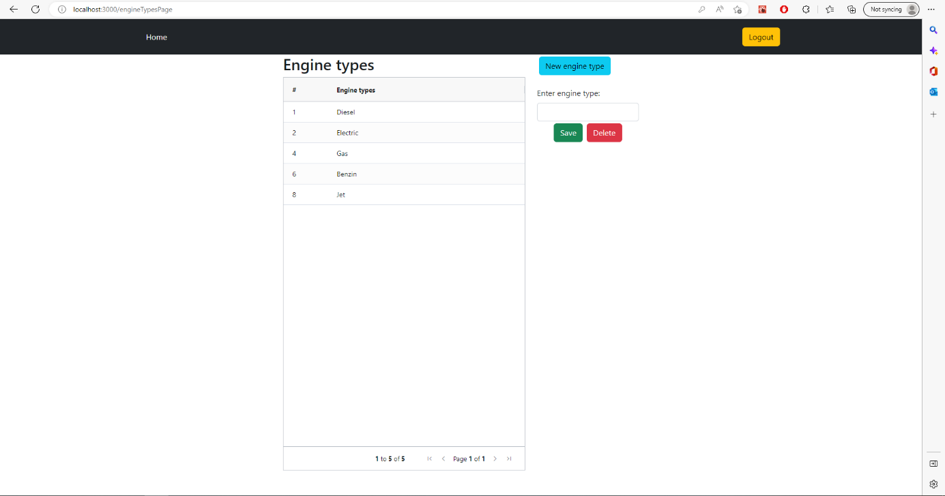

## 

## Gearboxes page

The gearboxes page is the final of the parameter pages. It has the same design and similar controls but this time the admins can create and edit the different types of gearboxes the cars offered on the website can have. Like the previous pages the feedback was positive and the page undertook little changes. Below you can see the final version of the gearboxes page.

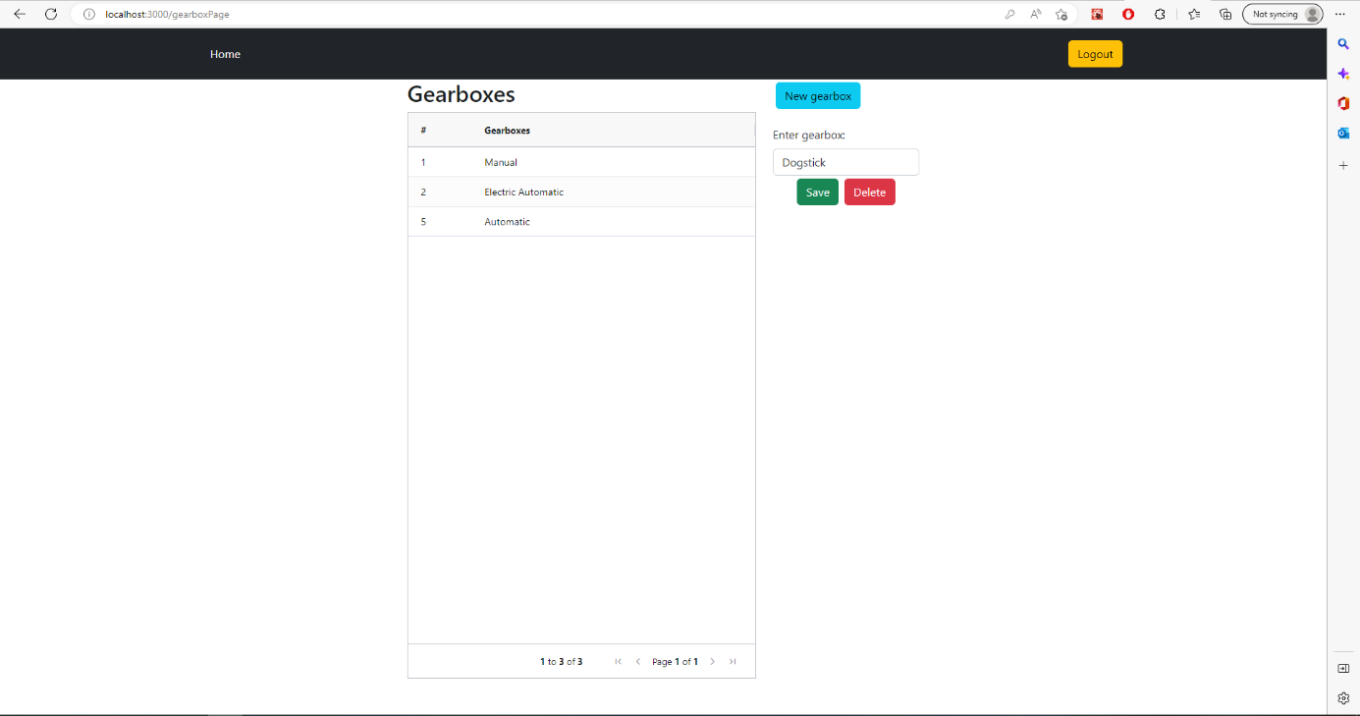

## Statistics page

The final page that is specifically for the admins is the statistics page. It consists of two pie charts that each show general information about the advertisements available on the website. You can see these in the picture below.

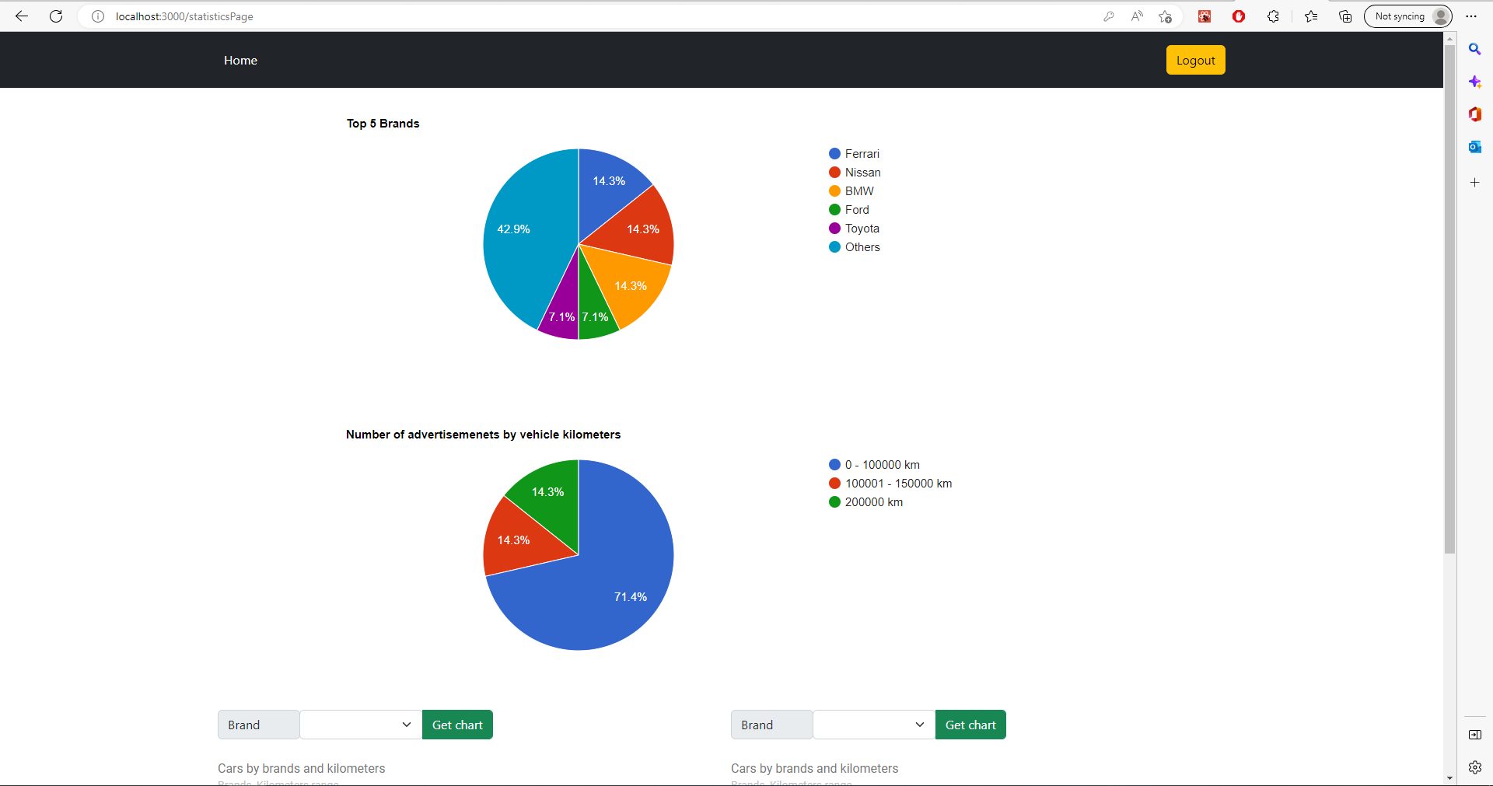

The feedback for the pie charts was positive and the test users determined that the charts were easy to read and understand.

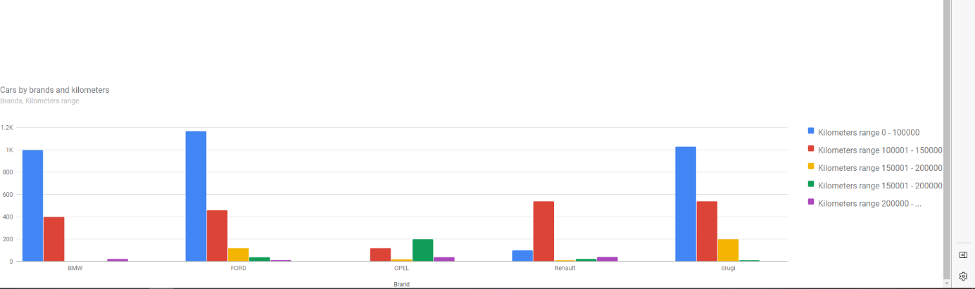The initial idea for the bar chart below was to display for all the brands on the website the number of adverts for each brand. However, the test users decided that that chart was hard to read and understand and it was changed. Below you can see the old version of the chart.

The redesign of the chart was quite drastic. The chart was split in two parts. These two bar charts can be used together to compare the number of advertisements for each brand. The users found it much easier to understand and navigate and overall, it was a positive change. Below you can see the final version of the bar charts.

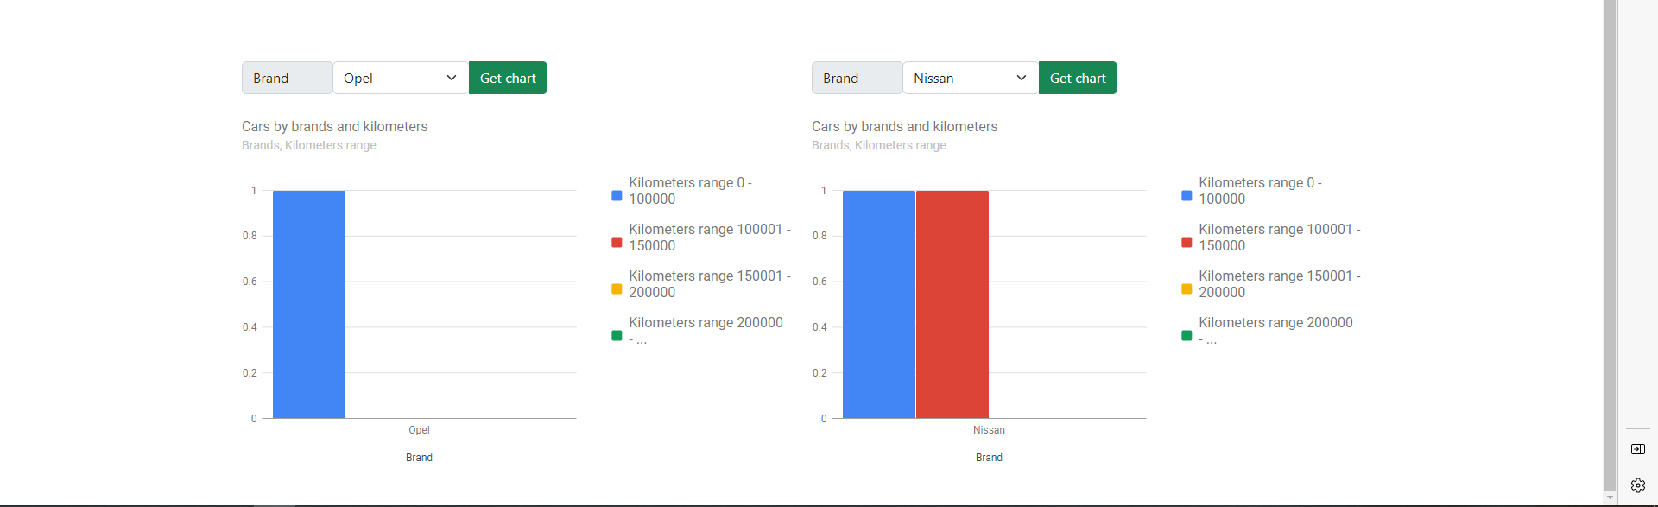

# Conclusion

To conclude this report, the feedback from the users was very helpful and thanks to it the application evolved to a much better looking and feeling website application. All of the feedback was taken into account and was used for basis for the changes made to the UI. The results are very positive and the CarShop application has become a user friendly and convenient website application.